2018 Advertising Rates and Information
Ohio Golf Journal is a monthly digital magazine, launched in January 2015, with delivery to over 72,000 email addresses in Ohio. Each issue of Ohio Golf Journal is posted to the website: http://ohiogolfjournal.com/, which increases SEO and views for advertisers.
Distribution: A new issue is distributed the second Wednesday of every month.
Advertising Requirements:
Full page ad: 8 x 10.5
1/2 page ad: 8 x 5.25 or 10.5 x 4
1/4 page ad: 4 x 5.25 or 10.5 5 x 2

Deadline: 25th of the preceding month

2018 Advertising Rates:
Size of ad: | 6 Mos. Commitment | 12 Mos. Commitment | 6 Month Prepay | One Year Prepay
Full Page | $450/mo. | $400/mo. | $2,700 | $4,800
Half Page | $250/mo. | $200/mo. | $1,500 | $2,400
1/4 Page | $150/mo. | $100/mo. | $900 | $1,200
Cover | $1,200 includes 4-page feature

Published by: , Back 9 Media Group
Contact: Fred Altvater, 419-344-3062 email: Fred@Back9MediaGroup.com

Page layout options:
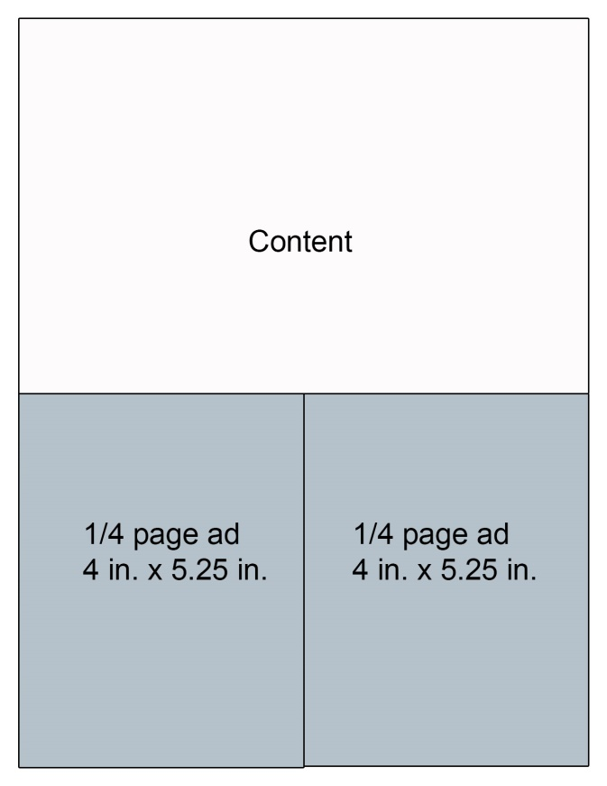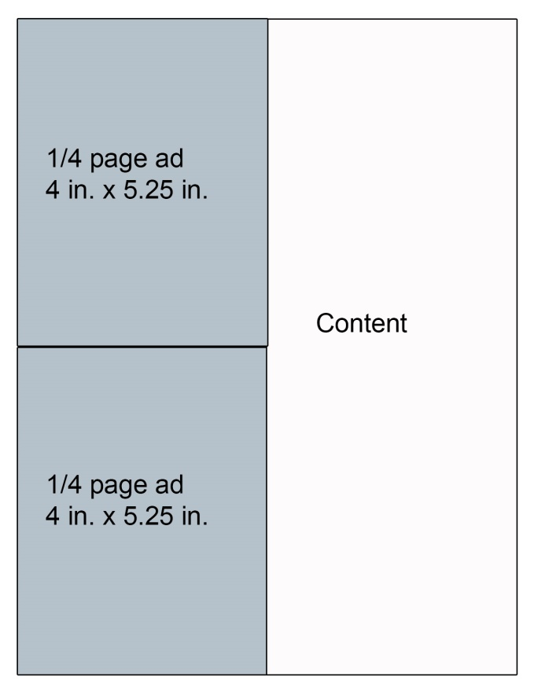
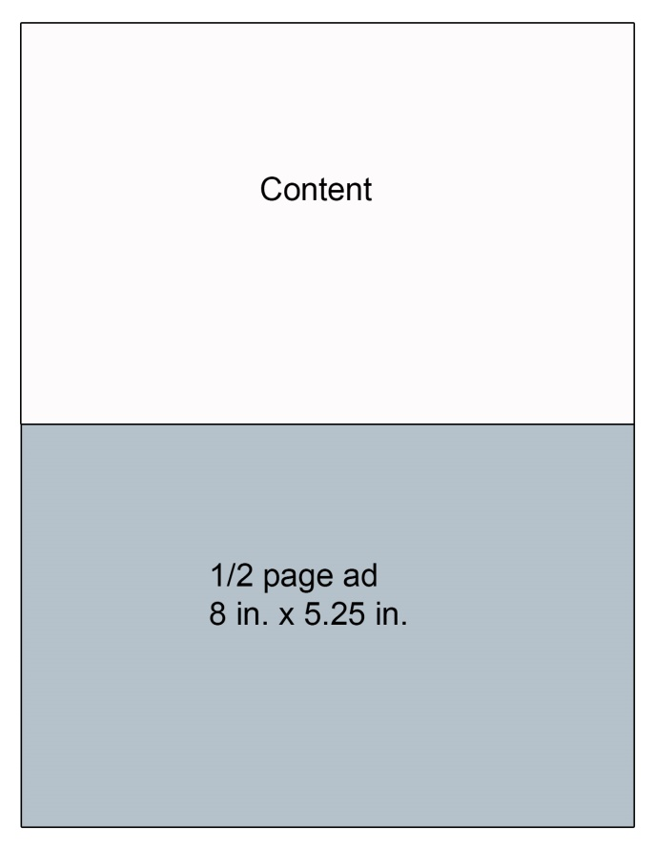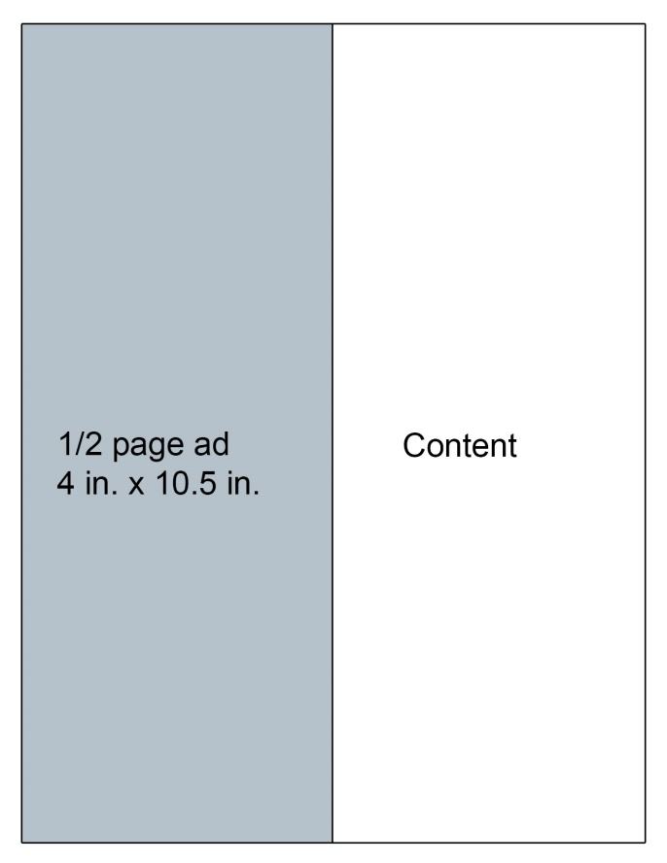

Advertiser Agreement
TERMS
- All rates are net to Back 9 Media Group
- 12 month prepay due upon agreement ; monthly payments are due on 25th of preceding month
- Fee based on receiving 150 dpi resolution ad artwork
- Any additional benefits received by either party must be outlined and agreed to in writing
- Oral agreements are not binding on either party
- Back 9 Media Group reserves the right to decline any advertising it deems unacceptable
ADVERTISER LEVEL: Choose level
Size of ad: | 6 Mos. Commitment | 12 Mos. Commitment | 6 Month Prepay | One Year PrePay
Full Page
Half Page
1/4 Page
1/8 Page

Billing Information:
Credit Card Number: _________________________________________
Exp Date: __________________ 3 Digit Code: _____________
Business Name: _________________________________________
Email Address: _______________________________________________
Billing Address:
Please return completed form to: Back 9 Media Group
Phone: 419-344-6613; fred@back9mediagroup.com
6062 Wood Dr.
Waterville, OH 43566
__________________________________________
__________________________________________
Phone: [ ] _____________________
Signature ___________________________________

